TERMS OF REFERENCE FOR AN AGRICULTURAL COMPLIANCE STATEMENT OR AGRICULTURAL AGRO-ECOSYSTEM SPECIALIST ASSESSMENT

PROPOSED CONSTRUCTION OF THE N7 VISSERSHOK WEIGHBRIDGE ON FARM 153 VISSERSHOK OUTSPAN WITHIN THE CITY OF CAPE TOWN MUNICIPALITY, WESTERN CAPE

1. INTRODUCTION
Sharples Environmental Services cc (SES) has been appointed as the independent Environmental Assessment Practitioner (EAP) to conduct the Environmental Assessments for the Proposed Construction of the N7 Vissershok Weighbridge on a portion of Farm 153 Vissershok Outspan within the City of Cape Town (CoCT) Municipality, Western Cape. At present, there is an established and operational weighbridge approximately 600m south of the proposed new weighbridge site. The proposed new weighbridge will replace the currently established weighbridge, which will be demolished, and the site rehabilitated.

1.1 Location of the proposal
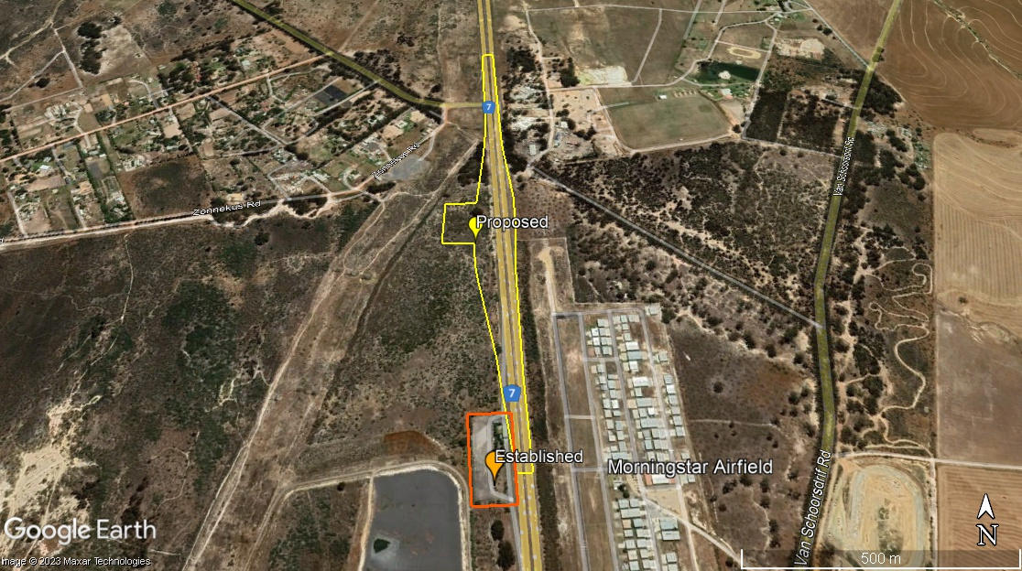
Figure 1: Weighbridge Locality Map (Orange: Established, Yellow: Proposed)

A screening report was completed on the 3rd of August 2023. With a “Very High” environmental sensitivity rating in terms of the Terrestrial Biodiversity Theme, and a “High” environmental sensitivity rating in terms of the Agriculture Theme, Animal Species Theme, Plant Species Theme and also Civil Aviation Theme. It is further indicated that the proposed site is located within the Strategic Transmission Corridor, Strategic Gas Pipeline Corridors and within the South African Conservation Areas Development Zone.

Figure 2: Suggested DEA Screening Tool sensitivity – Agricultural Theme

Table 1: Sensitivity features as per Screening Tool – Agricultural Theme
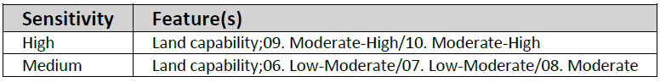

Figure 3: Suggested DEA Screening Tool sensitivity – Terrestrial Biodiversity Theme

Table 2: Sensitivity features as per Screening Tool – Terrestrial Biodiversity Theme
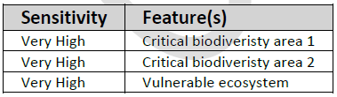

2. Specialist involvement
The purpose of this study is to verify the Agricultural Specialist input required for the proposed development, based on the site verification. Once established if a Compliance Statement/Impact Assessment is required, the specialist must inform the EAP, and thereafter provide the relevant statement/assessment in line with the requirement of the Protocol for the Specialist Assessment and Minimum Report Content Requirements of Environmental Impacts on Agricultural Resources, to inform the environmental assessment. The report should not be limited to this brief. Where the specialist sees the necessity for providing other vital information or investigations, this should be included.

The specialist conducting this study must:
- Be independent and have expertise in conducting similar assessments.
- Have a suitable academic qualification in the relative field.
- Be registered with the South African Council for Natural Scientific Professionals (SACNASP).
- Be familiar with the assessment criteria commonly used in the EIA Process to assess and evaluate impacts, as well as the newly promulgated Procedures for the Assessment and Minimum Criteria for Reporting on Identified Environmental Themes (March 2020).
- Have good knowledge relating to assessment techniques and to relevant legislation, policies and guidelines.
- Perform the work in an objective manner, even if this results in views and findings that are not favourable to the applicant.

2.1 Terms of Reference
The assessment of the proposal will necessitate specialist input which will need to be undertaken within the Terms of Reference listed below and relevant specialist guidelines. In addition to meeting the requirements of the relevant legislation, the compliance statement should also meet those of the Guideline for involving Specialists in EIA Processes and the relevant Gazetted Protocols. The Agricultural specialist must have no financial or other vested interest in the proposed development and must be professionally registered with the South African Council for Natural Scientific Professionals (SACNASP).

Phase 1 (Status Quo of Study Area & Site Visit & Baseline Report)
- Undertake site sensitivity verification including:
- a desktop analysis, using satellite imagery;
- a preliminary on-site inspection; and
- any other available and relevant information.
- The outcome of the site sensitivity verification must be recorded in the form of a report that:
- confirms or disputes the current use of the land and the environmental sensitivity as identified by the screening tool, such as new developments or infrastructure, the change in vegetation cover or status etc.;
- contains a motivation and evidence (e.g. photographs) of either the verified or different use of the land and environmental sensitivity; and
- is submitted together with the relevant assessment report prepared in accordance with the requirements of the Environmental Impact Assessment Regulations.
- A baseline description of the agro-ecosystem must be provided. The Baseline description must explain any current agricultural activities, the existing environmental attributes and impacts on any alternative sites.
- Identify and list all legislation and permit requirements that are relevant to the development proposal in context of the study.
- Detailed features required of the baseline description is provided in the Gazetted Protocols, this includes:
- The assessment must be undertaken based on a site inspection as well as an investigation of the current production figures, where the land is under cultivation or has been within the past 5 years, and must identify:
- the extent of the impact of the proposed development on the agricultural resources; and
- whether or not the proposed development will have an unacceptable impact on the agricultural production capability of the site, and in the event where it does, whether such a negative impact is outweighed by the positive impact of the proposed development on agricultural resources.
- The status quo of the site must be described, including the following aspects which must be considered as a minimum in the baseline description of the agroecosystem:
- the soil form/s, soil depth (effective and total soil depth), top and sub-soil clay percentage, terrain unit and slope;
- where applicable, the vegetation composition, available water sources as well as agro-climatic information;
- the current productivity of the land based on production figures for all agricultural activities undertaken on the land for the past 5 years, expressed as an annual figure and broken down into production units;
- the current employment figures (both permanent and casual) for the land for the past 3 years, expressed as an annual figure; and
- existing impacts on the site, located on a map (e.g. erosion, alien vegetation, non-agricultural infrastructure, waste, etc.).
- Confirm Sensitivity of the Site.
- Based on the findings the specialist is to heed the section 1.1. of the protocol which indicates that, “An applicant intending to undertake an activity identified in the scope of this protocol on a site identified by the screening tool as being of “very high” or “high” sensitivity for agricultural resources must submit an Agricultural Agro-Ecosystem Specialist Assessment, unless:
1.1.1. the application includes a linear activity for which impacts to the agricultural resource are temporary and the land in the opinion of the soil scientist or agricultural specialist, based on the mitigation and remedial measures, can be returned to the current land capability within two years of the completion of the construction phase;
1.1.2. the impact on agricultural resources is from an electricity pylon; or
1.1.3. information gathered from the site sensitivity verification differs from the designation of “very high” or “high” agricultural sensitivity, and it is found to be of a “medium” or “low” sensitivity.
1.2. Should paragraphs 1.1.1; 1.1.2; or 1.1.3 apply, an Agricultural Compliance Statement must be submitted.
Phase 2, if applicable (Compliance Statement Content)
- The compliance statement must be prepared by a soil scientist or agricultural specialist registered with the SACNASP.
- be applicable to the preferred site and proposed development footprint;
- confirm that the site is of “low” or “medium” sensitivity for agriculture; and
- indicate whether or not the proposed development will have an unacceptable impact on the agricultural production capability of the site.
- The compliance statement must contain, as a minimum, the following information:
- contact details and relevant experience as well as the SACNASP registration number of the soil scientist or agricultural specialist preparing the assessment including a curriculum vitae;
- a signed statement of independence;
- a map showing the proposed development footprint (including supporting infrastructure) with a 50m buffered development envelope, overlaid on the agricultural sensitivity map generated by the screening tool;
- calculations of the physical development footprint area for each land parcel as well as the total physical development footprint area of the proposed development including supporting infrastructure;
- confirmation that the development footprint is in line with the allowable development limits;
- confirmation from the specialist that all reasonable measures have been taken through micro-siting to avoid or minimise fragmentation and disturbance of agricultural activities;
- a substantiated statement from the soil scientist or agricultural specialist on the acceptability, or not, of the proposed development and a recommendation on the approval, or not, of the proposed development;
- any conditions to which this statement is subjected;
- in the case of a linear activity, confirmation from the agricultural specialist or soil scientist, that in their opinion, based on the mitigation and remedial measures proposed, the land can be returned to the current state within two years of completion of the construction phase;
- where required, proposed impact management outcomes or any monitoring requirements for inclusion in the EMPr; and
- a description of the assumptions made and any uncertainties or gaps in knowledge or data.
Phase 3, if applicable (Agricultural Agro-Ecosystem Specialist Assessment)
- The assessment must be undertaken by a soil scientist or agricultural specialist registered with the South African Council of Natural Scientific Professionals (SACNASP).
- The assessment must be undertaken on the preferred site and within the proposed development footprint.
- The assessment must be undertaken based on a site inspection as well as an investigation of the current production figures, where the land is under cultivation or has been within the past 5 years, and must identify:
- the extent of the impact of the proposed development on the agricultural resources; and
- whether or not the proposed development will have an unacceptable impact on the agricultural production capability of the site, and in the event where it does, whether such an impact is outweighed by the positive impact of the proposed development on agricultural resources.
- The assessment must include a description of the status quo, including the following aspects which must be considered as a minimum in the baseline description of the agro-ecosystem:
- the soil form/s, soil depth (effective and total soil depth), top and sub-soil clay percentage, terrain unit and slope;
- the soil form, soil depth (effective and total soil depth), top and sub-soil clay percentage, terrain unit and slope;
- where applicable, the vegetation composition, available water sources as well as agro-climatic information;
- the current productivity of the land based on production figures for all agricultural activities undertaken on the land for the past 5 years, expressed as an annual figure and broken down into production units;
- the current employment figures (both permanent and casual) for the land for the past 3 years, expressed as an annual figure; and
- existing impacts on the site, located on a map (e.g. erosion, alien vegetation, non-agricultural infrastructure, waste, etc.).
- The assessment must include an assessment of impacts, including the following aspects which must be considered as a minimum in the predicted impact of the proposed development on the agro-ecosystem:
- change in productivity for all agricultural activities based on the figures of the past 5 years, expressed as an annual figure and broken down into production units;
- change in employment figures (both permanent and casual) for the past 5 years expressed as an annual figure; and
- any alternative development footprints within the preferred site which would be of “medium” or “low” sensitivity for agricultural resources as identified by the screening tool and verified through the site sensitivity verification.
- The findings of the Agricultural Agro-Ecosystem Specialist Assessment must be written up in an Agricultural Agro-Ecosystem Specialist Report that contains as a minimum the following information:
- details and relevant experience as well as the SACNASP registration number of the soil scientist or agricultural specialist preparing the assessment including a curriculum vitae;
- a signed statement of independence by the specialist;
- the duration, date and season of the site inspection and the relevance of the season to the outcome of the assessment;
- a description of the methodology used to undertake the on-site assessment inclusive of the equipment and models used, as relevant;
- a map showing the proposed development footprint (including supporting infrastructure) with a 50m buffered development envelope, overlaid on the agricultural sensitivity map generated by the screening tool;
- an indication of the potential losses in production and employment from the change of the agricultural use of land as a result of the proposed development;
- an indication of possible long term benefits that will be generated by the project in relation to the benefits of the agricultural activities on the affected land;
- additional environmental impacts expected from the proposed development based on the current status quo of the land including erosion, alien vegetation, waste, etc.;
- information on the current agricultural activities being undertaken on adjacent land parcels;
- a motivation must be provided if there were development footprints identified as per paragraph 2.5.3 above that were identified as having a “low” or “medium” agriculture sensitivity and that were not considered appropriate;
- confirmation from the soil scientist or agricultural specialist that all reasonable measures have been considered in the micro-siting of the proposed development to minimise fragmentation and disturbance of agricultural activities;
- a substantiated statement from the soil scientist or agricultural specialist with regards to agricultural resources on the acceptability or not of the proposed development and a recommendation on the approval or not of the proposed development;
- any conditions to which this statement is subjected;
- where identified, proposed impact management outcomes or any monitoring requirements and/or mitigation measures for inclusion in the Environmental Management Programme (EMPr);
- a description of the assumptions made and any uncertainties or gaps in knowledge or data;
- calculations of the physical development footprint area for each land parcel as well as the total physical development footprint area of the proposed development (including supporting infrastructure);
- confirmation whether the development footprint is in line with the allowable development limits set in Table 1 above, including where applicable any deviation from the set development limits and motivation to support the deviation, including:
- where relevant, reasons why the proposed development footprint is required to exceed the limit;
- where relevant, reasons why this exceedance will be in the national interest; and
- where relevant, reasons why there are no alternative options available including evidence of alternatives considered; and
- a map showing the renewable energy facilities within a 50km radius of the proposed development.
- The findings of the Agricultural Agro-Ecosystem Assessment must be incorporated into the Basic Assessment Report or the Environmental Impact Assessment Report, including the mitigation and monitoring measures as identified, which are to be contained in the EMPr.
- A signed copy of the full Agricultural Agro-Ecosystem Assessment must be appended to the Basic Assessment Report or Environmental Impact Assessment Report.
General
- Reference all sources of information and/or data used.
- Indicate limitations and assumptions, particularly in relation to seasonality.
- Description of the methodology adopted in preparing the report.
- Provide a reasoned opinion as to whether the proposed activity should be authorised.
- The specialist and the report must comply with the following guidelines and legislation: Procedures for the assessment and minimum criteria for reporting on identified environmental themes in terms of Sections 24(5)(A) and (H) and 44 of the National Environmental Management Act, 1998, when applying for Environmental Authorisation.
- The report should be prepared in a suitable font and submitted to SES in draft form.
- Ensure it is clear that the mitigation hierarchy has been applied, in order, when recommendations and mitigation is applied.
- Ensure that there are no conflicting recommendations or conclusions.

2.2 Quotation Details
Please provide a written quote for all Phases, including:
- a break-down of costs;
- an indication of your earliest availability to commence the work;
- timeframes to conduct activities and for report deliveries, including baseline report, final reports, etc. where applicable.

3. Expected deliverables
All baseline studies to advise the scoping report, must be issued to the EAP by no later than 30th September 2022. The final detailed report must be issued to the EAP by no later than the 31st of October 2022.

All reports should cover the requirements detailed in section 2.1, be prepared in a suitable font (such as Arial 12) and the format and content must comply with Appendix 6 of the amended EIA Regulations, 2017, as well as the Promulgated Protocol for the Specialist Assessment and Minimum Report Content Requirements of Environmental Impacts on Agricultural Resources by Onshore Wind and/or Solar Photovoltaic Energy Generation Facilities Where the Electricity Output is 20 Megawatts or More (dated March 2020).

The EAP must be provided with an opportunity to comment on the initial draft before finalising. Please provide a written quote to compile both Scoping and Impact Assessment Phase reports, including:
- a break-down of costs,
- timeframes of all activities,
- and an indication of your earliest availability to commence the study.
Please note: If any of the mitigation measures recommended in the specialist report require additional plans for implementation that need to form a part of the Environmental Management Programme, the specialist is required to compile the report or provide support to the EAP in terms of reviewing the plan that the EAP compiles and ensuring that detailed specialist input is provided in this report. The specialist is further expected to provide responses (specialist input) on the comments received from I&APs during the public participation process, if related to the aspect they have addressed.

