TERMS OF REFERENCE FOR AN ANIMAL SPECIES & BIODIVERSITY
ASSESSMENT / COMPLIANCE STATEMENT

PROPOSED CONSTRUCTION OF THE N7 VISSERSHOK WEIGHBRIDGE ON FARM 153 VISSERSHOK (C1038: UPGRADING OF TR11/1), CITY OF CAPE TOWN MUNICIPALITY, WESTERN CAPE

1. INTRODUCTION
Sharples Environmental Services cc (SES) has been appointed as the independent Environmental Assessment Practitioner (EAP) to conduct the Environmental Assessments for the Proposed Construction of the N7 Vissershok Weighbridge on a portion of Farm 153 Vissershok (C1038: Upgrading of TR11/1), City of Cape Town (CoCT) Municipality, Western Cape. At present, there is an established and operational weighbridge approximately 500m south of the proposed new weighbridge site. The proposed new weighbridge will replace the established weighbridge, which will be demolished, and the site rehabilitated.

  - Location of the proposal
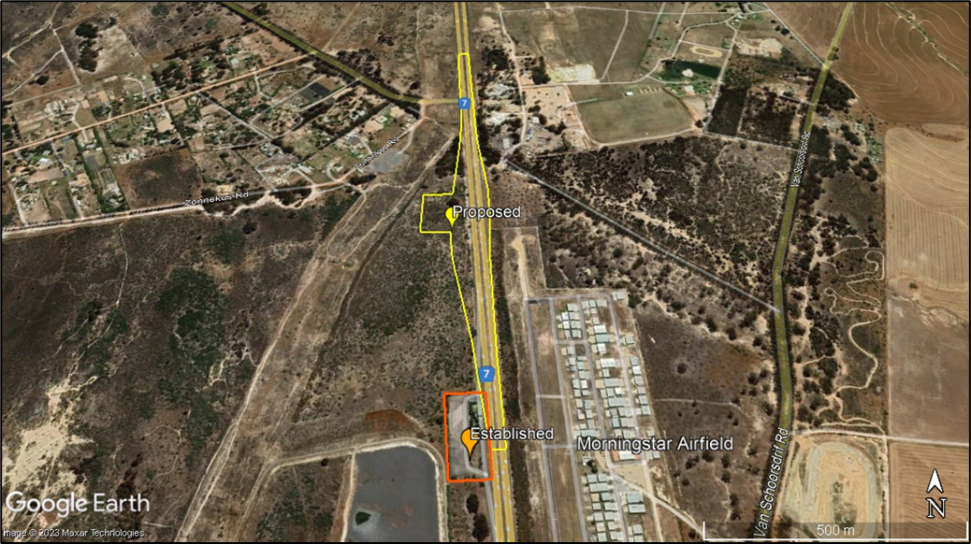
Figure 1: Locality Map

A screening report was completed on the 3rd of August 2023. With a “Very High” environmental sensitivity rating in terms of the Terrestrial Biodiversity Theme, and a “High” environmental sensitivity rating in terms of the Agriculture Theme, Animal Species Theme, Plant Species Theme and Civil Aviation Theme. It is further indicated that the proposed site is located within the Strategic Transmission Corridor, Strategic Gas Pipeline Corridors and within the South African Conservation Areas Development Zone. Therefore, Specialist input is required to address this sensitivity.

Figure 2: Screening Tool Report indicated High Sensitivity
Table 1: Features (DEA Screening Tool)
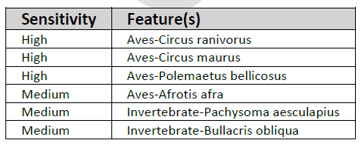

2. SPECIALIST INVOLVEMENT
The purpose of this study is to determine if a Terrestrial Animal Species Specialist Assessment or a Compliance Statement is required, by ascertaining the status and presence of the Species of Conservation Concern and assess the potential impact of the proposed development on the biophysical environment.
Thereafter, either a Terrestrial Animal Species Specialist Assessment or a Compliance Statement should be undertaken, based on the presence of SCC, as per the Gazetted Protocol:
https://screening.environment.gov.za/ScreeningDownloads/AssessmentProtocols/Gazetted_Animal_Species_Assessment_Protocols.pdf

The report should not be limited to this brief. Where the specialist sees the necessity for providing other vital information or investigations, this should be included.

The specialist conducting this study must:
- Be independent and have expertise in conducting similar assessments.
- Have a suitable academic qualification in the relative field.
- Be registered with the South African Council for Natural Scientific Professionals (SACNASP).
- Be familiar with the assessment criteria commonly used in the EIA Process to assess and evaluate impacts, as well as the newly promulgated Procedures for the Assessment and Minimum Criteria for Reporting on Identified Environmental Themes (March 2020) and the Animal Species Guideline.
- Have good knowledge relating to assessment techniques and to relevant legislation, policies and guidelines.
- Perform the work in an objective manner, even if this results in views and findings that are not favourable to the applicant.

2.1 Terms of Reference
The assessment of the proposal will necessitate specialist input which will need to be undertaken with the Terms of Reference listed below and relevant specialist guidelines. In addition to meeting the requirements of the relevant legislation, the Terrestrial Animal Species Assessment or Compliance Statement should also meet those of the Guideline for Involving Biodiversity Specialists in EIA Processes and the relevant Gazetted Protocols. The Terrestrial Biodiversity specialist must have no financial or other vested interest in the proposed development and must be professionally registered with the South African Council for Natural Scientific Professionals (SACNASP).

Phase 1 (Status Quo Assessment)
- The assessment must contextualize the study area in order to provide a baseline description of the ecological system, the terrestrial biodiversity and any significant terrestrial features must be provided.
- The assessment must identify the following;
  - Potential for habitat or ecosystem on receiving environment, if any.
  - Potential for Species of Conservation Concern (SCC) or lack thereof.
  - Confirmation of the presence or lack of, of animal features identified in the screening tool.
- Undertake a site visit and ground-truth biodiversity information. Where required, undertake baseline surveys and/or studies to supplement the information base and inform the assessment. The site inspection to determine the presence or likely presence of SCC must be undertaken in accordance with the Species Environmental Assessment Guidelines.
- Estimate the trajectory of change in the context of the ‘No-Go’ Alternative due to existing impacts.
- Assessment criteria to be aligned with the promulgated Procedures for the Assessment and Minimum Criteria for Reporting on Identified Environmental Themes (October 2020).
- The Specialist must inform the EAP of the final outcome of the baseline study for scoping, advising whether a compliance statement or impact assessment was applicable.
Phase 2: (If a Compliance Statement is Required)

- The Compliance Statement must:
- be applicable to the study area;
- confirm that the study area, is of “low” sensitivity for terrestrial animal species; and
- indicate whether or not the proposed development will have any impact on SCC.
- Minimum requirements include:
- contact details and relevant experience as well as the SACNASP registration number of the specialist preparing the compliance statement including a curriculum vitae;
- a signed statement of independence by the specialist;
- a statement on the duration, date and season of the site inspection and the relevance of the season to the outcome of the assessment;
- a description of the methodology used to undertake the site survey and prepare the compliance statement, including equipment and modelling used where relevant;
- the mean density of observations/ number of samples sites per unit area.
- where required, proposed impact management actions and outcomes or any monitoring requirements for inclusion in the EMPr (if none are required, this should be stated);
- a description of the assumptions made and any uncertainties or gaps in knowledge or data; and
- any conditions to which the compliance statement is subjected

Phase 2 (If a Terrestrial Animal Species Specialist Assessment Report is Required)
- In accordance with the Gazetted Protocols, the findings of the assessment must be written up in a Terrestrial Animal Species Specialist Assessment Report.
- A baseline study must be provided to advise the scoping phase of the EIA, and thereafter a detailed impact assessment must be provided.
- Terrestrial Animal Species Specialist Assessment Report must include the following;
  - The Identification, prediction and description of potential impacts on terrestrial ecology during the construction and operational phases of the project. Impacts are described in terms of their extent, intensity, and duration. The other aspects that must be included in the evaluation are probability, reversibility, irreplaceability, mitigation potential, and confidence in the evaluation.
  - This must be undertaken for all the alternatives and must be rated with and without mitigation to determine the significance of the impacts.
  - The degree to which the impacts and risks can cause loss of irreplaceable resources.
  - Recommend actions that should be taken to avoid impacts on sensitive ecology, in alignment with the mitigation hierarchy, and any measures necessary to restore disturbed areas or ecological processes.
  - Identify areas of high importance or sensitivity on which impacts should preferably be avoided or prevented or, where they cannot altogether be avoided, should at least be minimised (e.g. through buffers or setbacks).
  - Identify areas that are known to be important for biodiversity but are degraded or invaded by alien species and require rehabilitation/restoration, including areas that could improve connectivity and reduce fragmentation in the landscape.
  - An accurate description and map of the areas and features of importance to biodiversity and their sensitivity to the proposed development. Possibly recommend alternatives.
  - Rehabilitation guidelines for disturbed areas associated with the proposed project.
  - Any monitoring protocol that is deemed necessary
- A substantiated statement, based on the findings of the specialist assessment, regarding the acceptability, or not, of the proposed development, if it should receive approval or not must be included.
- As a minimum, as per the Gazetted Protocol (October 2020), the assessment must be undertaken in accordance with the Species Environmental Assessment Guideline; and must;
- identify the SCC which were found, observed or are likely to occur within the study area;
- provide evidence (photographs or sound recordings) of each SCC found or observed within the study area, which must be disseminated by the specialist to a recognized online database facility (the preferred platform is iNaturalist.org but any other national or international virtual museum), immediately after the site inspection has been performed;
- identify the distribution, location, viability and provide a detailed description of population size of the SCC, identified within the study area;
- identify the nature and the extent of the potential impact of the proposed development on the population of the SCC located within the study area;
- determine the importance of the conservation of the population of the SCC identified within the study area, based on information available in national and international databases, including the IUCN Red List of Threatened Species, South African Red List of Species, and/or other relevant databases;
- determine the potential impact of the proposed development on the habitat of the SCC located within the study area;
- include a review of relevant literature on the population size of the SCC, the conservation interventions as well as any national or provincial species management plans for the SCC. This review must provide information on the need to conserve the SCC and indicate whether the development is compliant with the applicable species management plans and if not, include a motivation for the deviation;
- identify any dynamic ecological processes occurring within the broader landscape that might be disrupted by the development and result in negative impact on the identified SCC, for example, fires in fire-prone systems;
- identify any potential impact of ecological connectivity in relation to the broader landscape, resulting in impacts on the identified SCC and its long term viability;
- determine buffer distances as per the Species Environmental Assessment Guidelines used for the population of each SCC;
- discuss the presence or likelihood of additional SCC including threatened species not identified by the screening tool, Data Deficient or Near Threatened Species, as well as any undescribed species (should be assessed as “High Sensitivity); or roosting and breeding or foraging areas used by migratory species where these species show significant congregations, occurring in the vicinity; and
- identify any alternative development footprints within the preferred site which would be of “low” or “medium” sensitivity as identified by the screening tool and verified through the site sensitivity verification.
General
- Reference all sources of information and/or data used.
- Indicate limitations and assumptions, particularly in relation to seasonality.
- Description of the methodology adopted in preparing the report.
- Provide a reasoned opinion as to whether the proposed activity should be authorised.
- The specialist and the report must comply with the following guidelines and legislation:
- Procedures for the assessment and minimum criteria for reporting on identified environmental themes in terms of Sections 24(5)(A) and (H) and 44 of the National Environmental Management Act, 1998, when applying for Environmental Authorisation.
- Animal Species Guideline
- Fynbos forum. 2016. Ecosystem guidelines for environmental assessment in the Western Cape. Cape town.
- Brownlie, S. 2005. Guideline for involving biodiversity specialists in EIA processes: Edition 1. CSIR Report No ENV-S-C 2005 053 C. Republic of South Africa, Provincial Government of the Western Cape, Department of Environmental Affairs & Development Planning, Cape Town.
- Any national, provincial and municipal biodiversity and development planning documents must be consulted where available.
- The report should be prepared in a suitable font and submitted to SES in draft form.
- Minimum general requirements include:
- contact details and relevant experience as well as the SACNASP registration number of the specialist preparing the assessment including a curriculum vitae;
- a signed statement of independence by the specialist;
- a statement on the duration, date and season of the site inspection and the relevance of the season to the outcome of the assessment;
- a description of the methodology used to undertake the site sensitivity verification, impact assessment and site inspection, including equipment and modelling used where relevant;
- a description of the mean density of observations/number of sample sites per unit area12 and the site inspection observations;
- a description of the assumptions made and any uncertainties or gaps in knowledge or data;
- details of all SCC found or suspected to occur on site, ensuring sensitive species are appropriately reported;
- the online database name, hyperlink and record accession numbers for disseminated evidence of SCC found within the study area;
- the location of areas not suitable for development and to be avoided during construction where relevant;
- a discussion on the cumulative impacts;
- impact management actions and impact management outcomes proposed by the specialist for inclusion in the Environmental Management Programme (EMPr);
- a reasoned opinion, based on the findings of the specialist assessment, regarding the acceptability or not of the development and if the development should receive approval or not, related to the specific theme being considered, and any conditions to which the opinion is subjected if relevant; and
- a motivation must be provided if there were any development footprints identified as per paragraph
- above that were identified as having “low” or “medium” terrestrial animal species sensitivity and were not considered appropriate.
- Ensure it is clear that the mitigation hierarchy has been applied, in order, when recommendations and mitigation is applied.
- Ensure that there are no conflicting recommendations or conclusions.
- Ensure the EAP is provided with working files, ie: KML/KMZ/Shapefiles and if a buffer is recommended, please ensure relevant table of coordinates are provided.

2.2 Quotation Details
Please provide a written quote for all Phases, including:
- a break-down of costs;
- an indication of your earliest availability to commence the work;
- timeframes to conduct activities and for report deliveries, including baseline report, final detailed report, etc. where applicable.

3. EXPECTED DELIVERABLES
All reports should cover the requirements detailed in section 2.1, be prepared in a suitable font (such as Arial 12) and the format and content must comply with Appendix 6 of the amended EIA Regulations, 2017, as well as the Promulgated Protocol for the Specialist Assessment and Minimum Report Content Requirements for Environmental Impacts on Terrestrial Animal Species (October 2020) < https://screening.environment.gov.za/ScreeningDownloads/AssessmentProtocols/Gazetted_Animal_Species_Assessment_Protocols.pdf >.
If deemed necessary to undertake an Animal Species Compliance Statement, an initial draft compliance statement covering the above requirement must be submitted to SES two weeks after the notice to proceed with the above scope of work. The final compliance statement (which shall include any reasonable amendments in response to the EAP’s comments on the initial draft, if necessary), as well as field survey, shall be delivered within one week after receiving comments from the EAP.
If deemed necessary to undertake an Animal Species Impact Assessment, an initial draft report must be submitted to SES four weeks after the notice to proceed with above scope of work. The final report (which shall include any reasonable amendments in response to the EAP’s comments on the initial draft, if necessary) shall be delivered two weeks after receiving comments on the draft report from the EAP.
The EAP must be provided with an opportunity to comment on the initial draft before finalizing. Please provide a written quote to compile both Scoping and Impact Assessment Phase reports.
Please note: If any of the mitigation measures recommended in the specialist report require additional plans for implementation that need to form a part of the Environmental Management Programme, the specialist is required to compile the report or provide support to the EAP in terms of reviewing the plan that the EAP compiles and ensuring that detailed specialist input is provided in this report. The specialist is further expected to provide responses (specialist input) on the comments received from I&APs during the public participation process, if related to the aspect they have addressed.

