TERMS OF REFERENCE FOR A NID, PALAEONTOLOGICAL & ARCHAEOLOGICAL COMPLIANCE STATEMENT OR IMPACT ASSESSMENT (HIA IF APPLICABLE)

PROPOSED CONSTRUCTION OF THE N7 VISSERSHOK WEIGHBRIDGE ON FARM 153 VISSERSHOK OUTSPAN WITHIN THE CITY OF CAPE TOWN MUNICIPALITY, WESTERN CAPE

1. INTRODUCTION
Sharples Environmental Services cc (SES) has been appointed as the independent Environmental Assessment Practitioner (EAP) to conduct the Environmental Assessments for the Proposed Construction of the N7 Vissershok Weighbridge on a portion of Farm 153 Vissershok Outspan within the City of Cape Town (CoCT) Municipality, Western Cape. At present, there is an established and operational weighbridge approximately 600m south of the proposed new weighbridge site. The proposed new weighbridge will replace the currently established weighbridge, which will be demolished, and the site rehabilitated.

1.1 Location of the proposal

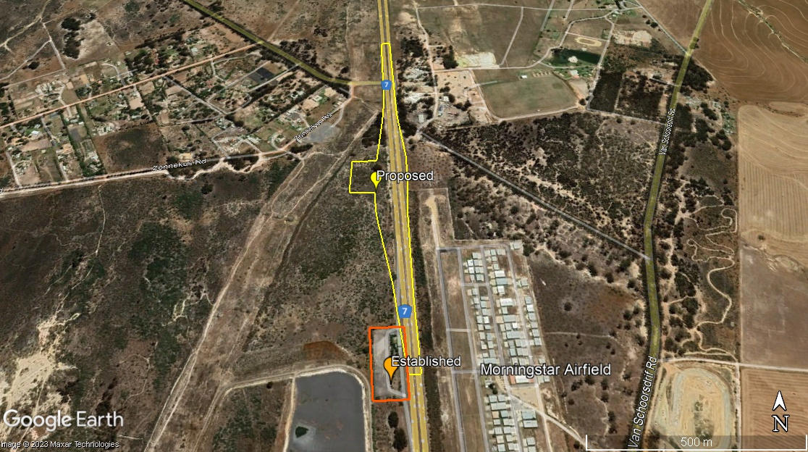
Figure 1: Location map

A screening report was completed on the 3rd of August 2023. With a “Very High” environmental sensitivity rating in terms of the Terrestrial Biodiversity Theme, and a “High” environmental sensitivity rating in terms of the Agriculture Theme, Animal Species Theme, Plant Species Theme and also Civil Aviation Theme. It is further indicated that the proposed site is located within the Strategic Transmission Corridor, Strategic Gas Pipeline Corridors and within the South African Conservation Areas Development Zone. For the Archaeological and Cultural Heritage Theme a “Low” environmental sensitivity rating was determined.

Figure 2: Suggested DEA Screening Tool sensitivity – Archaeological Theme.

Table 1: Sensitivity features as per Screening Tool Archaeological Theme.
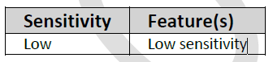

Figure 3: Suggested DEA Screening Tool sensitivity – Paleontological Theme.

Table 2: Sensitivity features as per Screening Tool Paleontological Theme.
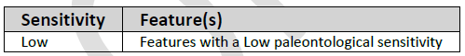

2. Specialist involvement
The purpose of this study is to conduct a Site Verification, to determine if a Compliance Statement or a Heritage Impact Assessment, will be required, to ascertain the status of the heritage resources and assess the potential impact of the proposed development on the resources. The report should not be limited to this brief. Where the specialist sees the necessity for providing other vital information or investigations, this should be included.

The specialist conducting this study must:
- Be independent and have expertise in conducting similar assessments.
- Have a suitable academic qualification in the relative field.
- Be registered with the Association of Professional Heritage Practitioners (APHP).
- Be familiar with the assessment criteria commonly used in the EIA Process to assess and evaluate impacts.
- Have good knowledge relating to assessment techniques and to relevant legislation, policies and guidelines.
- Perform the work in an objective manner, even if this results in views and findings that are not favourable to the applicant.

2.1 Terms of Reference
The assessment of the proposal will necessitate specialist input which will need to be undertaken with the Terms of Reference listed below and relevant specialist guidelines. The Heritage specialist must have no financial or other vested interest in the proposed development and must be professionally registered with APHP

Phase 1 (Status Quo Assessment – Site Verification) – Undertake and submit Notice of Intent to Develop to Heritage Western Cape
- The assessment must contextualize the study area in order to provide a baseline description of the heritage resources.
- Review available historic information the AIA.
- Review legal and planning context.
- Defining the Heritage and Aesthetic components of the environment.
- Analyze and identify the types of Historic resources present from tangibles like landscape, to intangibles like traditions, and knowledge.
- Determine the significance of the identified resources.
- Grade the heritage resources on site and the site in terms of its context in the landscape.
- Compile NID and submit with Compliance Statement, or if it is determined that an impact assessment is required, continue on with Phase 2.

Phase 2 (Assessment and analysis)
- The report must include a heritage resource analysis and constraints map.
- Provide an assessment of the character of the landscape to determine historic characteristics, scenic resources, historic sensitive areas and historic resources must be included
- Explain the correlation between the above to determine the varying levels of potential impact.
- Establish any further heritage constraints to guide the development process through establishing thresholds of impact significance.

Phase 3 (Impact Assessment)
- Assess the degree of and nature of significance.
- Assess both positive and negative impacts based on social history, public memory and cultural landscape information.
- Include an interpretation of the regional cultural landscape issues and the impact of the development in relation to these issues.
- Address heritage issues that arose during the process.
- Describe variables that could influence the historic landscape. 6. Incorporating the heritage related studies with an integrated set of recommendations
- Conclude the Heritage Impact and cumulate impacts.
- Suggest mitigating and management guidelines.
- A substantiated statement, based on the findings of the specialist assessment, regarding the acceptability, or not, of the proposed development, if it should receive approval or not must be included
General
- Reference all sources of information and/or data used.
- Indicate limitations and assumptions, particularly in relation to seasonality.
- Description of the methodology adopted in preparing the report
- Provide a reasoned opinion as to whether the proposed activity should be authorised
- The report should be prepared in a suitable font and submitted to SES in draft form.

2.2 Quotation Details
Please provide a written quote for all Phases, including:
- a break-down of costs;
- an indication of your earliest availability to commence the work;
- timeframes to conduct activities and for report deliveries, including baseline report, final reports, etc. where applicable.

3. Expected deliverables
All baseline studies to advise the scoping report, must be issued to the EAP by no later than 30th September 2022. The final detailed report must be issued to the EAP by no later than the 31st of October 2022.

All reports should cover the requirements detailed in section 2.1, be prepared in a suitable font (such as Arial 12) and the format and content must comply with Appendix 6 of the amended EIA Regulations, 2017.

The EAP must be provided with an opportunity to comment on the initial draft before finalizing. Please provide a written quote to compile both Scoping and Impact Assessment Phase reports, including:
- a break-down of costs,
- timeframes of all activities,
- and an indication of your earliest availability to commence the study.
Please note: If any of the mitigation measures recommended in the specialist report require additional plans for implementation that need to form a part of the Environmental Management Programme, the specialist is required to compile the report or provide support to the EAP in terms of reviewing the plan that the EAP compiles and ensuring that detailed specialist input is provided in this report. The specialist is further expected to provide responses (specialist input) on the comments received from I&APs during the public participation process, if related to the aspect they have addressed.

