TERMS OF REFERENCE FOR A TERRESTRIAL BIODIVERSITY COMPLIANCE STATEMENT OR A TERRESTRIAL BIODIVERSITY SPECIALIST ASSESSMENT

PROPOSED CONSTRUCTION OF THE N7 VISSERSHOK WEIGHBRIDGE ON FARM 153 VISSERSHOK OUTSPAN WITHIN THE CITY OF CAPE TOWN MUNICIPALITY, WESTERN CAPE

1. INTRODUCTION
Sharples Environmental Services cc (SES) has been appointed as the independent Environmental Assessment Practitioner (EAP) to conduct the Environmental Assessments for the Proposed Construction of the N7 Vissershok Weighbridge on a portion of Farm 153 Vissershok Outspan within the City of Cape Town (CoCT) Municipality, Western Cape. At present, there is an established and operational weighbridge approximately 600m south of the proposed new weighbridge site. The proposed new weighbridge will replace the currently established weighbridge, which will be demolished, and the site rehabilitated.

  - Location of the proposal
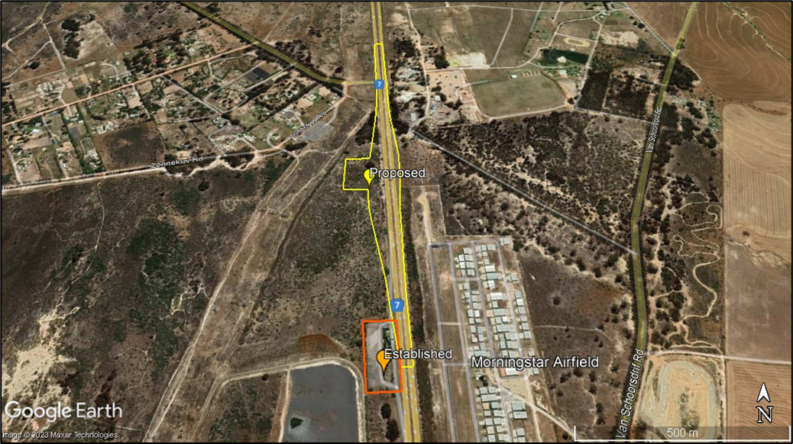
Figure 1: Locality Map.

A screening report was completed on the 3rd of August 2023. With a “Very High” environmental sensitivity rating in terms of the Terrestrial Biodiversity Theme, and a “High” environmental sensitivity rating in terms of the Agriculture Theme, Animal Species Theme, Plant Species Theme and also Civil Aviation Theme. It is further indicated that the proposed site is located within the Strategic Transmission Corridor, Strategic Gas Pipeline Corridors and within the South African Conservation Areas Development Zone.

As per the procedures for the assessment and minimum criteria for reporting on identified environmental themes (Terrestrial Biodiversity) in terms of Sections 24(5)(a) and (h) and 44 of the National Environmental Management Act, 1998, when applying for Environmental Authorisation (March 2020), “An applicant intending to undertake an activity identified in the scope of this protocol, on a site identified on the screening tool as being of “very high sensitivity” for terrestrial biodiversity, must submit a Terrestrial Biodiversity Specialist Assessment”. Therefore, specialist input is required in this regard.

Figure 2: Suggested DEA Screening Tool sensitivity.
Table 1: Sensitive features
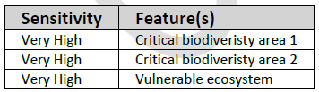

2. SPECIALIST INVOLVEMENT
The purpose of this study is to determine if a Terrestrial Biodiversity Assessment or a Compliance Statement is required. Either a Terrestrial Biodiversity Assessment or a Compliance Statement should be undertaken, as per the Gazetted Protocol:
https://screening.environment.gov.za/ScreeningDownloads/AssessmentProtocols/Gazetted_Terrestrial_Biodiversity_Assessment_Protocols.pdf
The specialist conducting this study must:
- Be independent and have expertise in conducting similar assessments;
- Have a suitable academic qualification in the relative field;
- Be registered with the South African Council for Natural Scientific Professionals (SACNASP and having expertise in the field of Terrestrial Biodiversity;
- Be familiar with the assessment criteria commonly used in the EIA Process to assess and evaluate impacts, as well as the newly promulgated Protocols related to the Procedures for the Assessment and Minimum Criteria for Reporting on Identified Environmental Themes (March 2020 & October 2020);
- Have good knowledge relating to assessment techniques and to relevant legislation, policies and guidelines.
- Perform the work in an objective manner, even if this results in views and findings that are not favourable to the applicant.

2.1 Terms of Reference
The assessment of the proposal will necessitate specialist input which will need to be undertaken with the Terms of Reference listed below and relevant specialist guidelines. In addition to meeting the requirements of the relevant legislation, the Terrestrial Biodiversity Specialist Assessment should also meet those of the Guideline for Involving Terrestrial Biodiversity specialists in EIA Processes and the relevant Gazetted Protocols:
https://screening.environment.gov.za/ScreeningDownloads/AssessmentProtocols/Gazetted_Terrestrial_Biodiversity_Assessment_Protocols.pdf.

The specialist must have no financial or other vested interest in the proposed development and must be professionally registered with the SACNASP.

Phase 1: (Baseline Study)
The assessment must provide a baseline description of the site which includes, as a minimum, the following aspects:
- A description of the ecological drivers or processes of the system and how the proposed development will impact these;
- A description of the ecological infrastructure, functioning, processes and services (e.g. fire, migration, pollination, etc.) that operate within the preferred site;
- A description of the ecological corridors that the proposed development would impede including migration and movement of flora and fauna;
- Indicate whether or not the proposed development will have any impact on biodiversity features;
- An indication and description of any significant terrestrial landscape features, including rare or important flora- faunal associations, presence of strategic water source areas (SWSAs) or freshwater ecosystem priority area (FEPA) sub catchments;
- A description of terrestrial biodiversity and ecosystems on the preferred site, including:
  - main vegetation types;
  - threatened ecosystems, including listed ecosystems as well as locally important habitat types identified;
  - ecological connectivity, habitat fragmentation, ecological processes and fine - scale habitats; and
  - species, distribution, important habitats (e.g. feeding grounds, nesting sites, etc.) and movement patterns identified;
  - Species of Conservation Concern
- Make reference to the allocated sensitivity as per the screening tool, state whether or not this sensitivity is accurate and recommend appropriate reclassification if it is not.
- The assessment must identify any alternative development footprints within the preferred site which would be of a “low” sensitivity as identified by the screening tool and verified through the site sensitivity verification.
- The specialist must confirm the need for either a Compliance Statement or an Impact Assessment.
Based on the results of a site visit, the following aspects are to be identified, discussed and applied to form the base for assessment:
- Terrestrial Critical Biodiversity Areas (CBAs), including:
  - the reasons why an area has been identified as a CBA;
  - an indication of whether or not the proposed development is consistent with maintaining the CBA in a natural or near natural state or in achieving the goal of rehabilitation;
  - percentage of site (erven/farm portions) covered by CBA
  - percentage of CBA (specify degraded/transformed and pristine) lost to proposed development layout alternatives (if layout is available).
  - the impact on species composition and structure of vegetation with an indication of the extent of clearing activities in proportion to the remaining extent of the ecosystem type(s);
  - the impact on ecosystem threat status;
  - the impact on explicit subtypes in the vegetation;
  - the impact on overall species and ecosystem diversity of the site; and
  - the impact on any changes to threat status of populations of species of conservation concern in the CBA;
  - Inclusion of any necessary buffer areas, including the identification of zones of sensitivity within the CBA that are priority to maintain ecological integrity.
- Terrestrial Ecological Support Areas (ESAs), including:
  - Percentage/quantity of site (erven/farm portions) covered by ESA
  - percentage of ESA lost to development (if layout is available)
  - the impact on the ecological processes that operate within or across the site;
  - the extent the proposed development will impact on the functionality of the ESA; and
  - loss of ecological connectivity (on site, and in relation to the broader landscape) due to the degradation and severing of ecological corridors or introducing barriers that impede migration and movement of flora and fauna;
  - Inclusion of any necessary buffer areas, including the identification of zones of sensitivity within the ESA that are priority to maintain ecological integrity.
- Protected areas as defined by the National Environmental Management: Protected Areas Act, 2004 including-
  - an opinion on whether the proposed development aligns with the objectives or purpose of the protected area and the zoning as per the protected area management plan;
- Priority areas for protected area expansion, including-
  - the way in which in which the proposed development will compromise or contribute to the expansion of the protected area network;
- SWSAs including:
  - the impact(s) on the terrestrial habitat of a SWSA; and
  - the impacts of the proposed development on the SWSA water quality and quantity (e.g. describing potential increased runoff)
- FEPA sub catchments, including-
  - the impacts of the proposed development on habitat condition and species in the FEPA sub catchment;
- Indigenous forests, including:
  - impact on the ecological integrity of the forest; and
  - percentage of natural or near natural indigenous forest area lost and a statement on the implications in relation to the remaining areas.
- Vegetation present onsite, including:
  - percentage of vegetation cover on the proposed site (erven/farm portions)
    - percentage of indigenous vegetation cover
    - percentage of alien invasive vegetation cover
  - percentage of vegetation cover to be lost due to development (provision of layouts depending)
    - percentage indigenous vegetation lost
    - percentage of alien invasive vegetation to be cleared
  - visualisation (map/illustration) of alien and indigenous vegetation loci.
- Identification of core ecosystem areas within the proposed site, as well as a description of the Ecosystem services and process provided.
- An indication and description of any Species of Conservation Concern
  - If search and rescue is recommended please provide a description of appropriate removal, maintenance and reinstatement methodology.
- Specify location of the areas not suitable for development, which are to be avoided during construction and operation (where relevant)
- Determine the need for a Compliance Statement or a Terrestrial Biodiversity Assessment Report, as per point 1: General Information of the Protocol for the Specialist Assessment and Minimum Report Content Requirements for Environmental Impacts on Terrestrial Biodiversity, it is stated:
- 1.3. However, where the information gathered from the site sensitivity verification differs from the designation of “very high” terrestrial biodiversity sensitivity on the screening tool and it is found to be of a “low” sensitivity, then a Terrestrial Biodiversity Compliance Statement must be submitted.
Phase 2: (If a Compliance Statement is Required)
- The compliance statement must be prepared by a specialist registered with the SACNASP and having expertise in the field of ecological sciences.
- The compliance statement must:
- be applicable to the preferred site and proposed development footprint;
- confirm that the site is of “low” sensitivity for terrestrial biodiversity; and
- indicate whether or not the proposed development will have any impact on the biodiversity feature.
- The compliance statement must contain, as a minimum, the following information:
- the contact details of the specialist, their SACNASP registration number, their field of expertise and a curriculum vitae;
- a signed statement of independence by the specialist;
- a statement on the duration, date and season of the site inspection and the relevance of the season to the outcome of the assessment;
- a baseline profile description of biodiversity and ecosystems of the site;
- the methodology used to verify the sensitivities of the terrestrial biodiversity features on the site, including equipment and modelling used, where relevant;
- in the case of a linear activity, confirmation from the terrestrial biodiversity specialist that, in their opinion, based on the mitigation and remedial measures proposed, the land can be returned to the current state within two years of completion of the construction phase;
- where required, proposed impact management outcomes or any monitoring requirements for inclusion in the EMPr;
- a description of the assumptions made and any uncertainties or gaps in knowledge or data; and
- any conditions to which this statement is subjected.
- A signed copy of the compliance statement must be appended to the Basic Assessment Report or Environmental Impact Assessment Report.
Phase 3: (If a Terrestrial Biodiversity Assessment Report is required)
The Terrestrial Biodiversity Specialist Assessment Report must discuss the following aspects:
- A description of the areas not suitable for development, which are to be avoided during construction and operation (where relevant);
- additional environmental impacts expected from the proposed development;
- any direct, indirect and cumulative impacts of the proposed development;
- the degree to which impacts and risks can be mitigated;
- the degree to which the impacts and risks can be reversed;
- the degree to which the impacts and risks can cause loss of irreplaceable resources;
- proposed impact management actions and impact management outcomes proposed by the specialist for inclusion in the Environmental Management Programme (EMPr);
- how the mitigation hierarchy was applied when determining mitigation measures and recommendations.
- a motivation must be provided if there were development footprints identified as the site verification visit, that were identified as having a “low” terrestrial biodiversity sensitivity and that were not considered appropriate;
- a substantiated statement, based on the findings of the specialist assessment, regarding the acceptability, or not, of the proposed development, if it should receive approval or not; and
- any conditions to which this statement is subjected.
- Identification of any buffer areas.
General
- Reference all sources of information and/or data used.
- Include contact details, relevant experience, CV and SACNASP registration number.
- A signed statement of independence by the specialist;
- A statement on the duration, date and season of the site inspection and the relevance of the season to the outcome of the assessment;
- A description of the methodology used to undertake the site survey, prepare the assessment, verify the sensitivities of the terrestrial biodiversity features on the site, including equipment and modelling used, where relevant.
- The assessment must be undertaken on the preferred site and within the proposed development footprint.
- Where required, proposed impact management actions and outcomes or any monitoring requirements for inclusion in the EMPr;
- A description of the limitations, assumptions made and any uncertainties or gaps in knowledge or data as well as a statement of the timing and intensity of site inspection observations;
- Any conditions to which the assessment is subjected.
- The specialist and the assessment must comply with the following guidelines and legislation:
- Procedures for the assessment and minimum criteria for reporting on identified environmental themes in terms of Sections 24(5)(A) and (H) and 44 of the National Environmental Management Act, 1998, when applying for Environmental Authorisation
- The assessment should be prepared in a suitable font and submitted to SES in draft form.
- Ensure it is clear that the mitigation hierarchy has been applied, in order, when recommendations and mitigation is applied.
- Ensure that there are no conflicting recommendations or conclusions.
- Ensure the EAP is provided with working files, ie: KML/KMZ/Shapefiles and if a buffer is recommended, please ensure relevant table of coordinates are provided.

2.2 Quotation Details
Please provide a written quote for all Phases, including:
- a break-down of costs;
- an indication of your earliest availability to commence the work;
- timeframes to conduct activities and for report deliveries, including baseline report, final reports, etc. where applicable.

3. Expected deliverables
All baseline studies to advise the scoping report, must be issued to the EAP by no later than 30th September 2022. The final detailed report must be issued to the EAP by no later than the 31st of October 2022.

All reports should cover the requirements detailed in section 2.1, be prepared in a suitable font (such as Arial 12) and the format and content must comply with Appendix 6 of the amended EIA Regulations, 2017, as well as the Promulgated Protocol for the Specialist Assessment and Minimum Report Content Requirements for Environmental Impacts on Terrestrial Biodiversity (March 2020) https://screening.environment.gov.za/ScreeningDownloads/AssessmentProtocols/Gazetted_Terrestrial_Biodiversity_Assessment_Protocols.pdf.

The EAP must be provided with an opportunity to comment on the initial draft before finalizing.
Please note: If any of the mitigation measures recommended in the specialist report require additional plans for implementation that need to form a part of the Environmental Management Programme, the specialist is required to compile the report or provide support to the EAP in terms of reviewing the plan that the EAP compiles and ensuring that detailed specialist input is provided in this report. The specialist is further expected to provide responses (specialist input) on the comments received from I&APs during the public participation process, if related to the aspect they have addressed.

